Blackboard Collaborate Cheat Sheets
If you need some visual quick tips and how-to reminders for using Blackboard Collaborate’s more advanced features, read on. This document covers Engagement and Assessment Ideas, How to Form Breakout Groups, and How to Share Documents for Collaboration.

Engagement and Assessment Ideas
Use the following strategies to engage students, check their understanding, practice their skills, collaborate, and hold them accountable for learning.

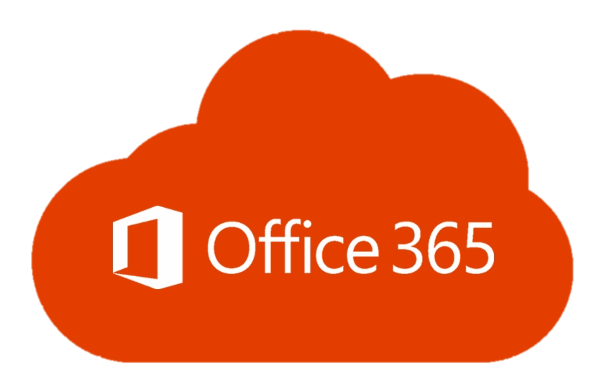
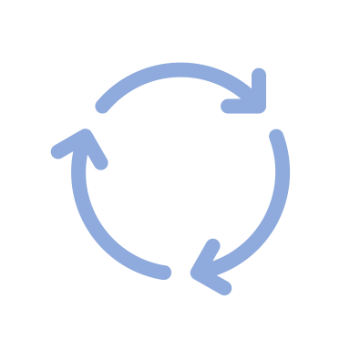
Use a combination of these to keep the class active.
Interrupt the flow and restart by switching speakers or content type.
Collaborate on Office 365 together.
Drop a link to a reading, video, tool, or interactive website in the chat.
Have students draw, type, and collaborate on the whiteboard or files.
Use breakouts for group work or think-pair-shares.
Ask students to use the hand raise icon when they have questions/comments.
Ask students to “raise your hand if…” to engage and get quick feedback.
Use polling to check for understanding, guide your instruction, or as informal formative assessment.
Ask for a chat emoji to gauge understanding or elicit reactions.
Ask students to share/comment in the chat. Award for “first-to” posts.

How To Form Breakout Groups
Follow the steps below to split your class into breakout groups. Remember to always click Start or Update after moving students or yourself. See Blackboard’s Collaborate: Breakout Groups page for more information.

1
In the Collaborate panel, click the Share icon.

3
2
Drag participants to groups for custom assignment or, if 4+ are present, you can select randomly assign. Click Start.

Click Breakout Groups.
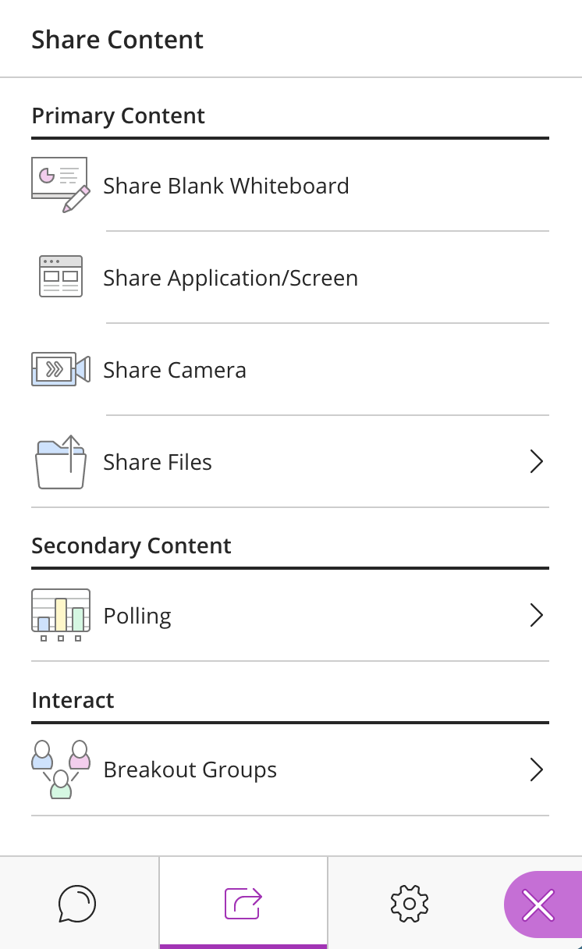

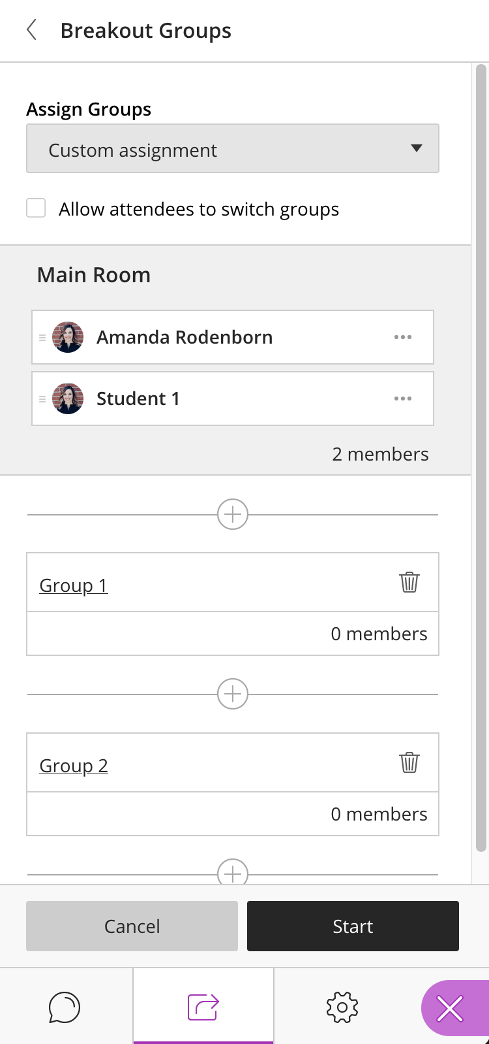
Drag

How to Share Documents for Collaboration
All DMACC students and employees have access to Microsoft Office 365 (the online versions of Word, Excel, PowerPoint, and more). Your students and you can create or upload documents here that are automatically stored in the cloud (your DMACC OneDrive for Business account). This makes it easy for you to share links to documents and collaborate with one another live.

Follow these steps to share a document in Collaborate and start collaborating!

- Log in to .
- Click .
- or create a document (saves to OneDrive) .
- Click (upper-right corner).
- Choose your settings (default allows editing) and click .
  - If you want to share with only one or a few people, you can enter a name/email address instead of copying and sharing the link. This will send an email containing the link directly to the individual(s). You can also add a brief message to send with the document.
- Paste the link into a document or on a digital sticky note to have at hand when you are teaching, or if you are teaching, paste it directly into the Collaborate chat to begin sharing.
  - Links shared in Collaborate chat are automatically clickable and will open in a new tab once clicked, keeping the Collaborate session open in its original tab.

Teach your students these steps to have them share documents with you and their classmates.

Students can also sync their OneDrive for Business account to Blackboard so they can submit documents they have worked on and saved to the cloud. See and share the Submitting Assignments Guide for Students (bottom of page 1 includes cloud syncing information).

Note: You can always check the version history of Office 365 documents if something was accidentally deleted or modified: File Info Version History.

Need Help?
If you need help, please contact one of our instructional designers.

